Longsheng Pipeline Equipment Materials Co., Ltd.

Rubber Expansion Joint Installation Guide
Single sphere, double sphere, large diameter and threaded rubber expansion joints
Most rubber joint failures start at installation, not in service. Follow these nine steps and check each one before the line is filled.

1. Before installation
- Check size, pressure class, rubber, face-to-face length and flange drilling against the order and the piping drawing.
- Inspect the rubber for cuts, cracks or damage from transport. Do not install a damaged joint.
- Store in a cool, dry and shaded place, away from ozone sources such as motors and welding equipment.
- Never lift or carry a joint by the rubber body or through the bore.

2. Anchor the pipe
The joint is not a pipe support. Under pressure it pushes the pipes apart with a force equal to the pressure times the effective area of the arch. Anchors on both sides must take this thrust; guides keep the pipe on its axis.
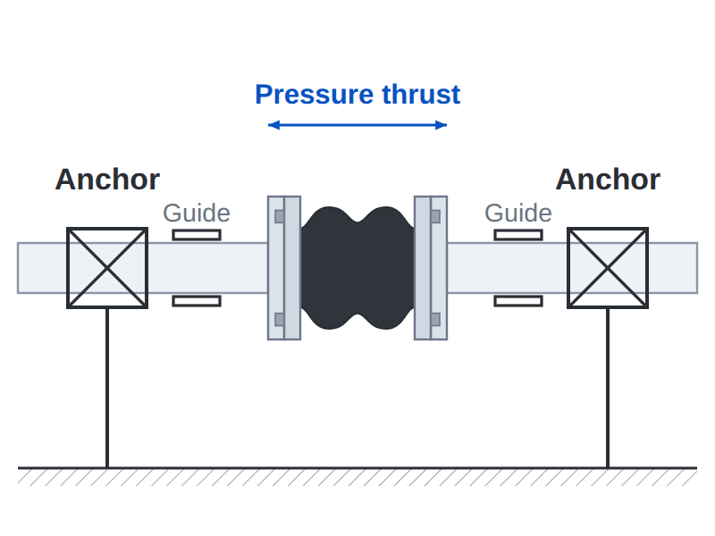
Anchor the pipe on both sides of the joint
- Support the weight of pipes, valves and pumps independently of the joint.
- Place the joint close to an anchor, with guides on the free side.

3. Control rods
Fit control rods where anchors cannot take the pressure thrust: at pump outlets, on equipment mounted on springs and on lines without anchors.
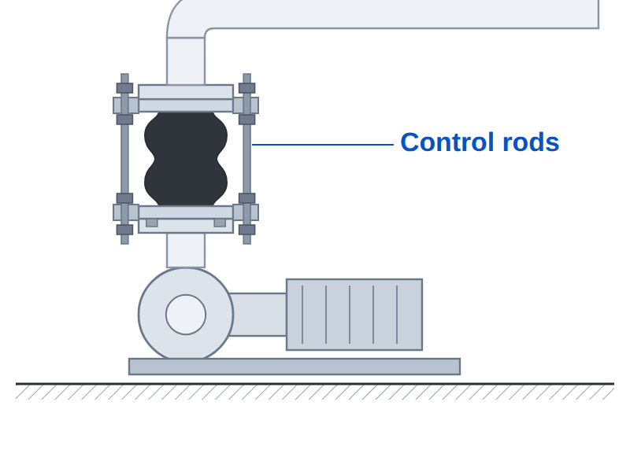
Control rods at a pump outlet
- Set the rod nuts to the maximum allowed extension of the joint, not tight against the gusset plates.
- Never use control rods to pull or push the joint to fill a gap.

4. Gap and alignment
Install the joint at the face-to-face length listed on the datasheet. Keep the gap within 3 mm of that length and the two flanges parallel and on one axis.
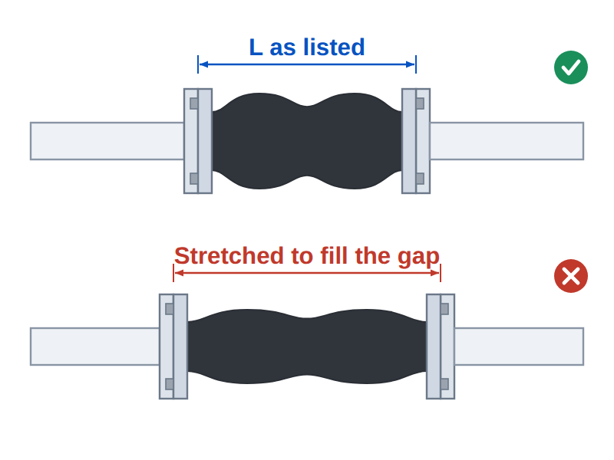
Right: listed length. Wrong: stretched to fill the gap
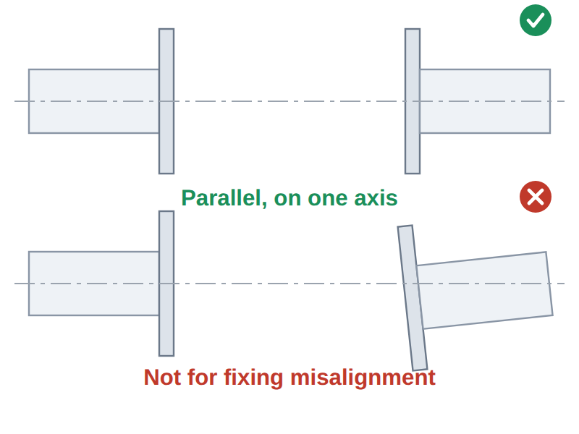
The joint is not for correcting misalignment

5. Mating flanges and bolting
- No gasket. The rubber face is the seal. Do not add a gasket.
- Full face contact. The mating flange must cover the full rubber face. Pipe ends must not stand proud of the flange face; remove weld spatter and sharp edges.
- Bolt direction. Insert bolts with the heads on the joint side and the nuts outside, so bolt ends cannot touch the arch.
- Cross pattern. Tighten in a cross pattern in three passes: hand tight, half torque, full torque. Stop when the rubber face bulges slightly and evenly at the flange edge.
- Re-tighten. Re-tighten after 24 hours and again after the pressure test.
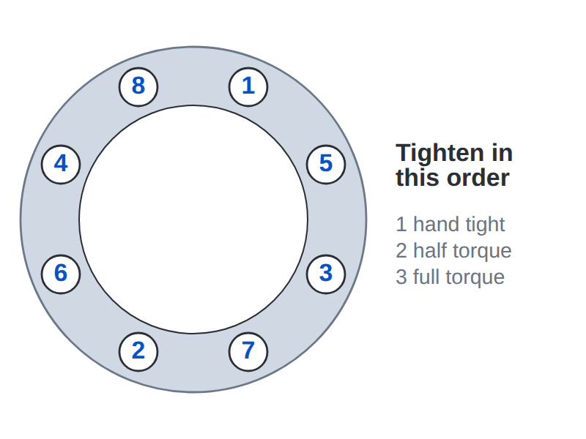
Cross pattern tightening sequence (8 bolts)

6. Protect the rubber
- Do not paint the rubber or clean it with solvents. Mask the joint when painting the line.
- Do not cover the joint with insulation unless it was ordered for it; trapped heat shortens rubber life.
- Shield the joint from welding sparks and cutting work nearby.
- Outdoors, protect NR and NBR joints from direct sunlight, or order an EPDM or CR cover.
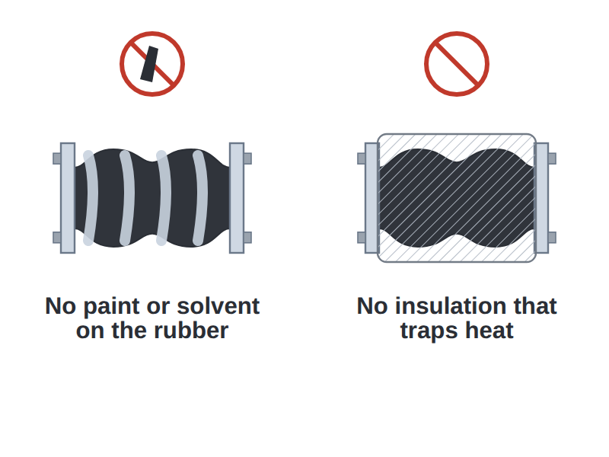
No paint and no insulation on the rubber

7. Large diameter joints
- Lift by the flanges or lifting lugs with slings. Never sling around the arch.
- Keep the transport bars in place until the joint is bolted in, then remove them before filling the line.
- Align the flanges before inserting the joint; follow the same cross pattern with more passes.
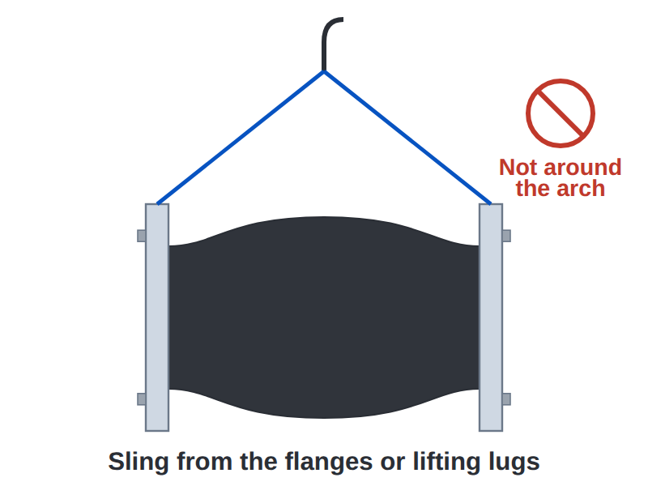
Lift by the flanges
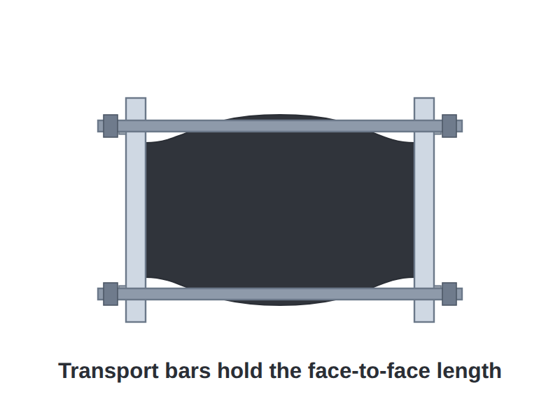
Transport bars hold the length during shipping

8. Threaded joints
- Check the thread type first: G (BSPP), R / Rc (BSPT) or NPT. BSPT and NPT look alike but do not seal together.
- Screw the union end onto the pipe with a wrench on the union end, using PTFE tape or sealant on taper threads.
- Tighten the union nut by hand, then a further quarter to half turn with a wrench. Never twist the rubber body.
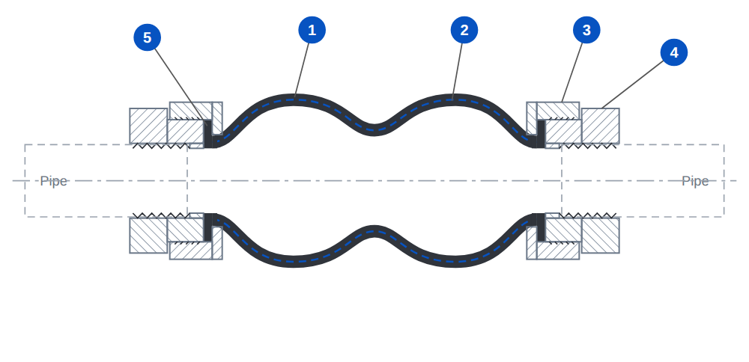
Threaded union joint: rubber lip clamped between union nut and union end

9. Pressure test and inspection
- The system test pressure must not exceed 1.5 × the rated working pressure of the joint.
- Check bolts and control rod nuts after the test.
- Inspect regularly for cracks, blisters, deformation or leaks. Replace any joint where the cord fabric shows through the rubber.

Questions about a specific installation? Send photos or the piping drawing to sales1@lsruberjoint.com or WhatsApp +86-15837196938.

